Important Kids Voting Information:

Kids Voting Southeast Pennsylvania
Adopt-A-Precinct Program

Helping Children At The Polls

- Contact your District Volunteer Coordinator with your selected “adopted” precinct(s). Precincts are "adopted” on a first come, first served basis.
- Make a personal visit or call to your "adopted" precinct site at the end of the summer to identify a suitable space for your Kids Voting polling station. Ask them to provide two or more tables and some chairs. Some polling sites have special restrictions.
- Communicate with your precinct Election Judge in mid-October to introduce yourself and assure them that Kids Voting will not interfere with the actual voting.
- Feel free to personalize your Kids Voting area. Make a sign with your school or organizations name. Bring balloons (some kids have latex allergy) or a poster with your mascot or logo. You deserve the credit and recognition!
- All Kids Voting precinct sites will be listed on our website (www.kidsvotngsoutheastpa.org) as well as in The Intelligencer and Bucks County Courier Times prior to Election Day.
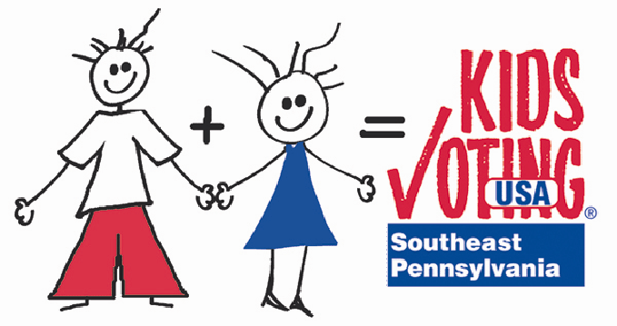
- KIDS VOTING POLLS WILL BE OPEN FROM 3:30PM T0 7:00PM ON TUESDAY, NOVEMBER 6, 2012
For more information please contact:
Richard O. Coe, Ed. D., Executive Director
Kids Voting Southeast Pennsylvania
P.O. Box 372, Washington Crossing, PA 18977
Phone: 215.205.6557
E Mail: rocoe@comcast.net

.,
1
- Choose a Precinct - Select one or two polling sites to "adopt" to represent your school or organization.
- Assign a Captain - Review the Precinct Captain list of responsibilities. Ask for a volunteer for this position.
- Recruit Volunteers - Adopted precincts will need 3-5 volunteers per shift to assist children through the voting process on Election Day.

The Role and Responsibilities of a Precinct Captain:

Prior to Election Day
- Recruit/schedule volunteers for each precinct. Each precinct will need
3-5 volunteers per shift plus some "alternates" as backup. Recommended shifts: Shift times to be determined by local district
Shift 1 (Set Up) 3:00 - 5:30 PM
Shift 2 (Tear down) 5:15 - 7:30 PM
- At least two weeks prior to Election Day, contact the person in charge at your polling site to make arrangements for a Kids Voting location (preferably a separate room). Be sure tables and chairs will be provided. Some polling sites have special restrictions.
- At least two weeks prior to Election Day, call the precinct judge to let him/her know that you are the KV precinct captain. Reassure the judge that Kids Voting will not interfere with the adult voting process,
- One week prior to election call to remind each volunteer of their shift/commitment. Please give volunteers your election night phone number.
- Mail, email or fax schedule of KV poll workers (names, addresses, phone) to your District Volunteer Coordinator, XXXX, by October XX.
- Distribute KV materials to volunteers - KV ballot boxes, voting booths, pencils, ballots, stickers. Prepare a sample ballot, highlighting appropriate sections of the ballot for students in K-3, 4-6 and 7-12.

Election Day (Tuesday, November 6th)
- Have first shift set up polls at 3:00 PM to be ready for voters at 3:30PM. Be there to supervise, if possible.
- Ensure that volunteers report to polls and get trained at each shift change.
- Assign someone to take completed ballots to KV district headquarters at 5:30PM for review (place in Ballot Envelope #1).
- Be on site or available for questions throughout Election Day. Leave your phone number(s) at the poll, along with list of KV Headquarter contact number(s).

Closing the Polls (7:30 PM)
- The Captain is responsible for getting final ballots to KV Headquarters when polls close. (Place in Ballot Envelope #2)
- Collect all supplies and tidy up Kids Voting polling sites. Supplies: extra ballots, pencils, ballot box, voting booths, registration sheets, “I Voted” stickers. These should be returned to KV headquarters.
- Clean up! Please restore the room to its original condition. Remove all trash. Remember, we are guests!

Facts about Kids Voting

- DEMOCRACY COMES ALIVE FOR YOUNG PEOPLE

Students, accompanied by a parent or guardian, vote on their own ballot.

The Kids Voting polling station will be in an area nearby or adjacent to the adult polls.

- AN AUTHENTIC VOTING EXPERIENCE FOR STUDENTS

Each Kids Voting polling station will be manned by 3-5 trained volunteers who have been recruited from school parent teacher organizations or local service clubs.

In most cases the Kids Voting polls will operate from 3:30 PM -7:30 PM.

- REGIONAL IMPACT

Kids Voting is endorsed by the County Commissioners and School Districts.

Kids Voting Southeastern Pennsylvania includes all thirteen Bucks County School Districts and two school districts in Eastern Montgomery County.

- NONPARTISAN

Kids Voting volunteers will not solicit votes, wear partisan insignia, or distribute partisan literature.

- SUPERVISION BY TRAINED VOLUNTEERS

Each Kids Voting polling station will be led by a precinct captain who will contact the Judge of Election prior to Election Day to make arrangements that will insure no disruption to the adult polling operation.

Kids Voting will be responsible for setting up and breaking down their station in a prearranged area.

The precinct captain will provide the Judge of Election with a list of authorized volunteers at least one week prior to Election Day.

Kids Voting volunteers will be responsible for maintaining order at their polling station.

